**QSMART – CG WIRING**

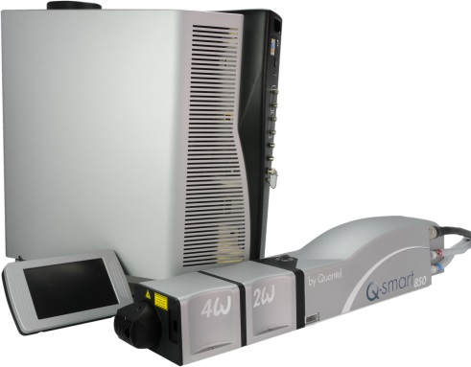

**Toolkit:**

Allen keys

**System**: QSMART

**Purpose:** This document details how to connect the cooling group wires

|  |  |  |
| --- | --- | --- |
| Revision | date | modification |
| Initial issue | July 4, 2014 |  |
|  |  |  |
|  |  |  |
|  |  |  |

# WIRING

|  |  |  |
| --- | --- | --- |
| 1.00 | V/CLS-M0416A2 | CLS M4-16 STAINLESS STEEL SCREW |
| 2.00 | E/H---M04—A2 | H M4 NUT |
| 3.00 | R/ZU—D04—A2 | ZU4 WASHER |

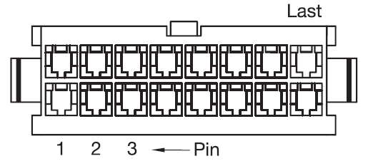

|  |  |
| --- | --- |
|  | Description |
| PIN.1 | Heater |
| PIN.2 | Temperature Switch – White wire |
| PIN.3 | Ground wire |
| PIN.4 | Pump – Black wire |
| PIN.5 | Fan – Black wire |
| PIN.6 | Water level sensor |
| PIN.7 | Water flow switch |
| PIN.8 | Temperature sensor |
| PIN.9 |  |
| PIN.10 | Heater |
| PIN.11 | Temperature Switch – Orange wire |
| PIN.12 | Ground wire |
| PIN.13 | Pump – Red wire |
| PIN.14 | Fan – Red wire |
| PIN.15 | Water level sensor |
| PIN.16 | Water flow switch |
| PIN.17 | Temperature sensor |
| PIN.18 | Fan – Orange wire |

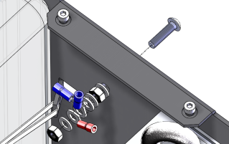

Ground wires

* 1 from heater
* 2 from connector

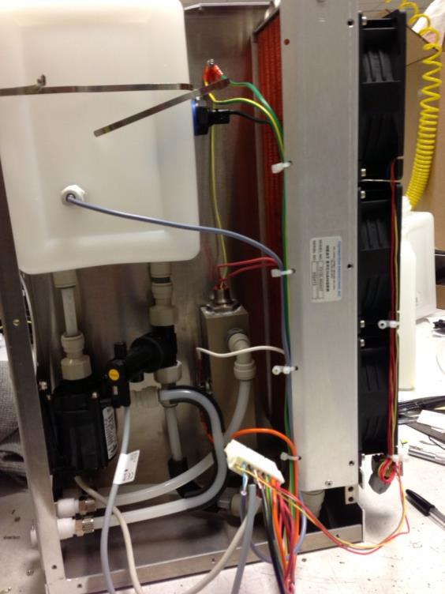

Plug here

(fans side)

Temp Switch

Orange wire connection

Fan wires connections

Respect colour code

Temp Switch

White wire connection

Use Tyrap cable ties as shown

Ground wires

